ELGIN SCOUTS
RISK ASSESSMENT FOR VISITS
Rugby 6 Nations Feb 2015

NAME OF DISTRICT/GROUP: …………………………1st Elgin Scouts (and 2nd Elgin)………………………………………………………………………………

NAME OF PERSON COMPLETING RISK ASSESSMENT/UPDATE: ……………Andre Govier………………………………………………………………

DATE OF RISK ASSESSMENT/UPDATE: ……………30/12/15………………………………………………………………………………………………..

The aim of a generic risk assessment is to provide general information on the type of hazards adults and young members (as well as others who may be involved) are exposed to.
The list given is by no means an exhaustive one. Hazards which are not listed but are specific to your visit should be recorded on the blank assessment form
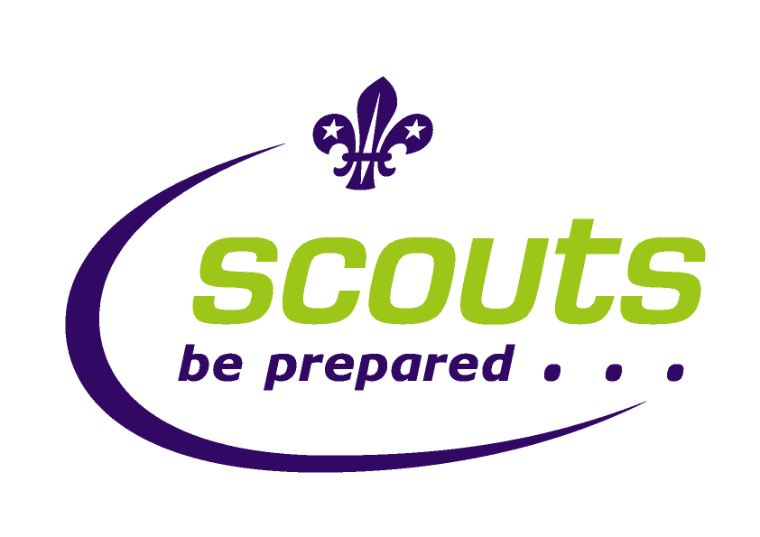

P.O.R rules relating to the Rugby

The only information we need to be aware of and comply with is the information contained in the general factsheets

Scout Led Activities

Activity | P.O.R Rules | Other information | Scouting Authorisation Required | Extra third party insurance required | Notification Required
Rugby – watching 6 nations match | - FS120000 Risk Assessment  - FS120088 Weather Forecasts in Outdoor Activities  - FS129999 Safety in Scouting:  - FS140048 – First aid kits  - FS120075 – In Touch  - FS155068 – Planning an Outing | Master doc | No  No  No  No  No  No | No  No  No  No  No  No | No  No  No  No  No  No

Risk assessment
Ratios | 1:12 max  For event we have 38 Scouts/siblings and 8 Leaders/section assistants. 1:4 ratio
Qualifications | - Paul or Andre event leader. If Andre offshore Paul will lead.  - Scouts leaders first aid qualified – various levels all at minimum requirement and above.  - All leaders and section assistants’ disclosure cleared.
Control Measures in force | - Appropriate first aid kit to be carried on coach  - A means of raising the alarm in an emergency to be established. (If reliant on mobile phone, ensure network coverage in area to be visited).  - In the event that the event leader or coach driver considers any or all of the route to or back from the rugby unsuitable due to weather or other hazards they have discretion to alter the route.  - In the event of an incident requiring one or more emergency services to be summoned the activity will be terminated immediately and the scouts and leaders taken home as quickly as possible and parents will be informed as required in the home contact guidelines.  - If any leader is unhappy they can cancel the event.

HAZARD | Risk before control Measure | Who is at risk | STEPS TO CONTROL RISK | RISK LEVEL if controls implemented | REVIEW AND DECISION
Driving -tiredness | High | All | Coach driver has his time limits – driver not watching rugby and will rest | low
Driving -Weather | High | All | Weather checked day before and morning before.  If weather unsuitable to drive – cancel.  Continually assess en-route | low
Driving -Breakdown | Med | All | Professional company with good reputation - Coach has current Mot and have been regularly serviced.  Maynes responsible for breakdown cover.  Keep the passengers in a safe position until either the problem is fixed or replacement transport arrives. Driver takes the lead with scout leaders assisting is req. | low
Driving -  Getting lost | Med | All | Professional company with good reputation – easy route to follow - will have satnav  No major deviation on route unless event leader agrees | low
Driving -  insurance | Med | All | Maynes coaches will have fully comp. Scout insurance covers scouts and leaders for additional. | low
Additional party members to travel in own cars | Med | Separate car | One leader driving down with his sons due to travel sickness.  They are covered under their own car insurance policy.  Tiredness – they are staying in Edinburgh so no issue. | low
Road Accident | Med | All | Driver to pay attention to relevant speed restrictions for the vehicle and roads travelled.  Seat belts fitted and to be worn.  Fastened at all times when the vehicle is in motion.  Do not overload the vehicle.  Exits must not be blocked with luggage or equipment.  Young people must not be allowed to move around the vehicle when it is in motion.  Young people must not distract the driver when the vehicle is in motion. | low
If road accident occurs | INFO | All | If the accident is not serious. On normal road keep passengers safe by remaining on the transport if it is safe to do so. If not move the passengers to a safe location protected from oncoming traffic. When moving follow the highway code and use staff to  Supervise the young people to avoid danger.  If the accident is serious move those able to walk away from the scene of the accident keeping them safe throughout. This will have to be assessed at the time. Deal with casualties as best as you can until emergency help arrives.  Control communications;  Contact emergency services 999,  Contact GSL, Neil 01343544989  District Commissioner Dougie 01343 821178,  Scout emergency Line  0845 3001818 or 07977 539 630 | NA
Diabetes | High | 1 Scouts | 1 scout attending have type 1 Diabetes. Medication to be carried both in minibus and at the game. Andre attending and trained/aware. | Low
Hypothermia | Medium | All | Ensure all on activity are dressed suitably for the weather on the day. | Low
Losing scouts at event | High | All | Operate ‘buddy’ system and maintain supervision –Scouts to wear identifying neckerchiefs  Scouts to be numbered off  Set ‘lost point’ position  Roll call before recommencing journey  Leader allocated 4-5 scouts each to take in and out of ground | Low
Travel sickness | High | All | Identify potential from health forms  Provide buckets / bags and bottles of water for journey Provide reassurance / occupation | Low

